URDF hip pitch

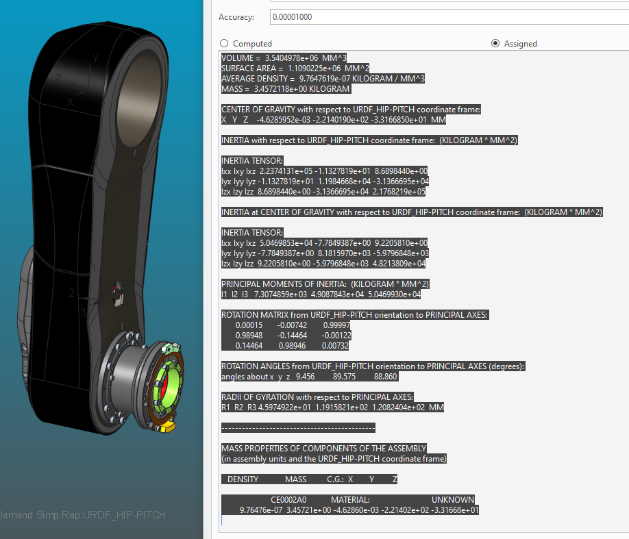

VOLUME = 3.5404978e+06 MM^3

SURFACE AREA = 1.1090225e+06 MM^2

AVERAGE DENSITY = 9.7647619e-07 KILOGRAM / MM^3

MASS = 3.4572118e+00 KILOGRAM

CENTER OF GRAVITY with respect to URDF_HIP-PITCH coordinate frame:

X Y Z -4.6285952e-03 -2.2140190e+02 -3.3166850e+01 MM

INERTIA with respect to URDF_HIP-PITCH coordinate frame: (KILOGRAM * MM^2)

INERTIA TENSOR:

Ixx Ixy Ixz 2.2374131e+05 -1.1327819e+01 8.6898440e+00

Iyx Iyy Iyz -1.1327819e+01 1.1984668e+04 -3.1366695e+04

Izx Izy Izz 8.6898440e+00 -3.1366695e+04 2.1768219e+05

INERTIA at CENTER OF GRAVITY with respect to URDF_HIP-PITCH coordinate frame: (KILOGRAM * MM^2)

INERTIA TENSOR:

Ixx Ixy Ixz 5.0469853e+04 -7.7849387e+00 9.2205810e+00

Iyx Iyy Iyz -7.7849387e+00 8.1815970e+03 -5.9796848e+03

Izx Izy Izz 9.2205810e+00 -5.9796848e+03 4.8213809e+04

PRINCIPAL MOMENTS OF INERTIA: (KILOGRAM * MM^2)

I1 I2 I3 7.3074859e+03 4.9087843e+04 5.0469930e+04

ROTATION MATRIX from URDF_HIP-PITCH orientation to PRINCIPAL AXES:

0.00015 -0.00742 0.99997

0.98948 -0.14464 -0.00122

0.14464 0.98946 0.00732

ROTATION ANGLES from URDF_HIP-PITCH orientation to PRINCIPAL AXES (degrees):

angles about x y z 9.456 89.575 88.860

RADII OF GYRATION with respect to PRINCIPAL AXES:

R1 R2 R3 4.5974922e+01 1.1915821e+02 1.2082404e+02 MM

---------------------------------------------

MASS PROPERTIES OF COMPONENTS OF THE ASSEMBLY

(in assembly units and the URDF_HIP-PITCH coordinate frame)

DENSITY MASS C.G.: X Y Z

CE0002A0 MATERIAL: UNKNOWN

9.76476e-07 3.45721e+00 -4.62860e-03 -2.21402e+02 -3.31668e+01

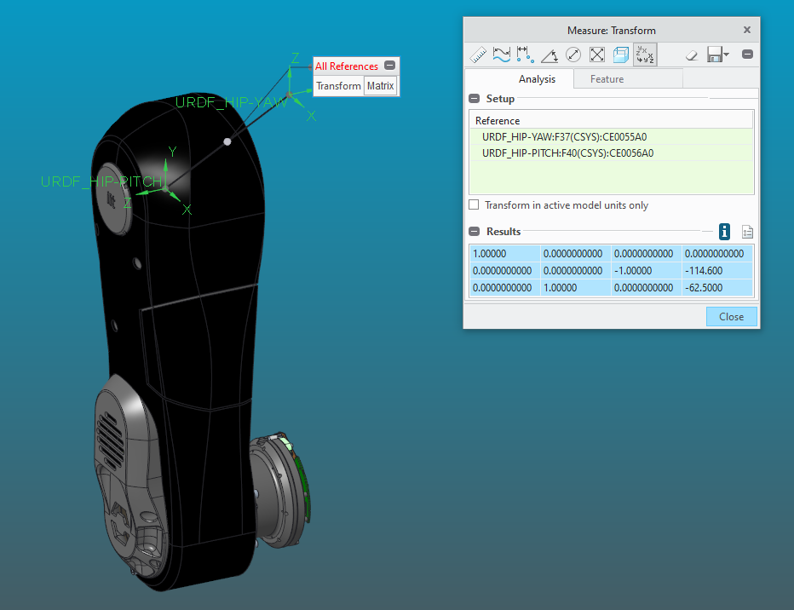

1.00000 0.0000000000 0.0000000000 0.0000000000

0.0000000000 0.0000000000 -1.00000 -114.600

0.0000000000 1.00000 0.0000000000 -62.5000